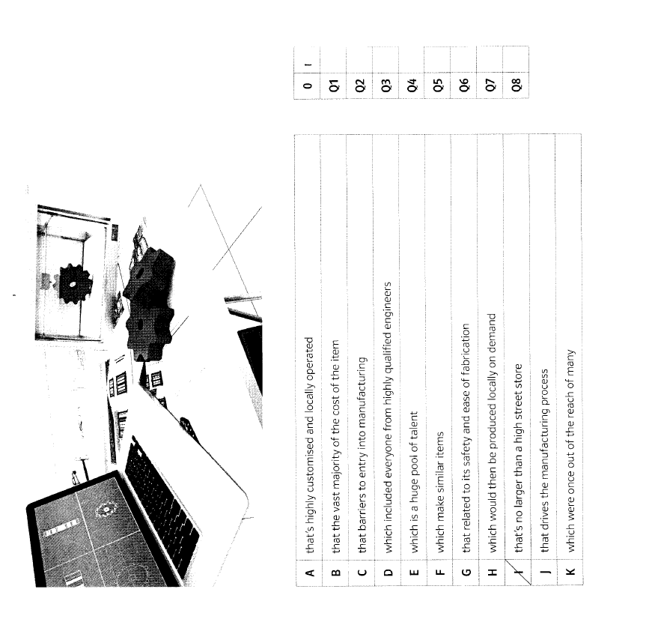**The future of manufacturing**

|  |  |
| --- | --- |
| 0 | I |
| Q1 | D |
| Q2 | G |
| Q3 | A |
| Q4 | K |
| Q5 | F |
| Q6 | B |
| Q7 | H |
| Q8 | C |